## Wireless brilliance remixed

**Sennheiser’s HD 458BT fuses new style to great wireless sound**

***Sydney/Wedemark, May 28, 2020 –* It’s time to fall in love again. Like a new version of a hit tune or a director’s cut of a favourite movie, there’s nothing like a remix to add to the magic. With the launch of the new HD 458BT special edition, audio specialist Sennheiser has given its HD 450BT over-ear wireless headphones a new look, with bold red accents that lift the minimalist design to stylish new heights. Their winning combination of brilliant customisable Sennheiser sound, active noise cancellation and 30-hour battery life make the headphones the ideal choice for audio lovers seeking to step up their everyday listening experience.**

“Like every well-made remix, the HD 458BT special edition keeps everything that is fantastic about the original while adding a fresh twist,” explains Jermo Köhnke, Product Manager at Sennheiser. “With the bold metallic red and minimalistic black exterior, they project a cool, assured style that hints at their brilliant audio performance.”

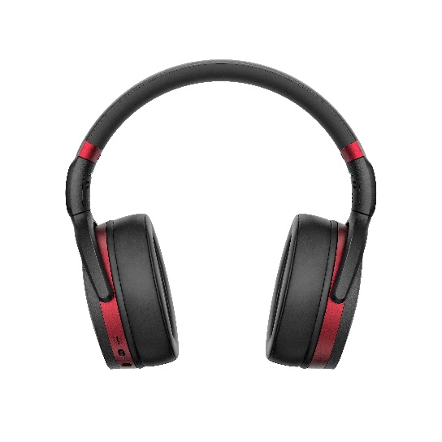

The HD 458BT features a fresh new look with bold red accents that lift the minimalist design to new heights

Thanks to active noise cancellation and a closed-back design, they ensure superior, distraction-free sound with deep dynamic bass – even in loud environments. This makes them perfect for creating an oasis of personal space or avoiding disturbing others nearby – whether you’re out and about or practicing social distancing in a home full of flatmates. Exceptional quality is assured by high-quality wireless codec support, including AAC and AptX™, with AptX™ Low Latency to keep audio perfectly in sync with on-screen action when watching videos.

**Make it yours with customisable sound**

Thanks to Sennheiser’s Smart Control App, the HD 458BT can be tailored to offer a truly personal experience. Its intuitive equalizer makes it effortless to enjoy more bass or select the perfect balance for one’s choice of music or entertainment. The Smart Control App also features a podcast mode to increase the intelligibility of podcasts, audio books and other speech content. The app further enhances ease of use with fast access to battery status, a Quick Guide for further tips, and fuss-free firmware updates.

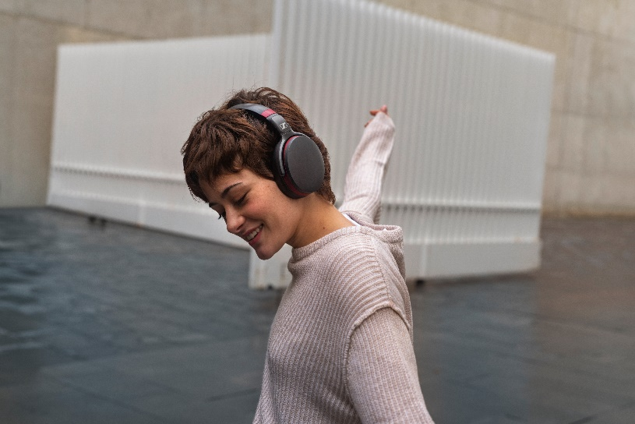

Using the Sennheiser Smart Control App, the HD 458BT can be tailored to offer a truly personal listening experience

**Perfect at home, perfect on the move**

With a superb 30-hour battery life, fast USB-C charging and compact folding design, the HD 458BT is a perfect companion for everyday life. The headphones have been made with Sennheiser’s characteristically high-quality materials and build quality for take-anywhere toughness and true ergonomic comfort. Whether at home or on the move, the new headset keeps the wearer connected, thanks to Bluetooth 5.0 support and a dedicated Voice Assistant button for at-a-touch voice interaction with Siri or Google Assistant. With the physical buttons on the earcups it is intuitive to control music and calls.

The HD 458BT can also be used in wired mode and comes supplied with an additional audio cable. A carry case is provided for convenient storage.

Available from the end of May, the new HD 458BT (RRP $299.95 AU / $329.95 NZ) is exclusive to select dealers in ANZ:

* Harvey Norman New Zealand: <https://www.harveynorman.co.nz/phone-and-gps/headphones/sennheiser-hd-458bt-wireless-over-ear-headphones.html>
* JB Hi-Fi Australia: <https://www.jbhifi.com.au/products/sennheiser-hd-458bt-over-ear-wireless-noise-cancelling-headphones-black-red>
* Sennheiser Australia: <https://en-au.sennheiser.com/hd-458bt>

About Sennheiser

Founded in 1945, Sennheiser is celebrating its 75th anniversary this year. Shaping the future of audio and creating unique sound experiences for customers – this aim unites Sennheiser employees and partners worldwide. The independent family company, which is managed in the third generation by Dr. Andreas Sennheiser and Daniel Sennheiser, is today one of the world’s leading manufacturers of headphones, loudspeakers, microphones and wireless transmission systems. In 2018, the Sennheiser Group generated turnover totaling €710.7 million. [www.sennheiser.com](http://www.sennheiser.com)

**Global Contact**

Jacqueline Gusmag

Communications Manager Consumer

[jacqueline.gusmag@sennheiser.com](mailto:jacqueline.gusmag@sennheiser.com)

T +49 (0)5130 600-1540

**Local Press Contact**

Gabby Wallace

[gabby.wallace@hausmann.com.au](mailto:gabby.wallace@hausmann.com.au)

0431 045 932